On Tuesday 23rd January, the photographer will visit nursery. If you would like a family photograph please bring your family along at the beginning of the session. The photographer will be in the class from the beginning of each session.
On Wednesday 24th January, the librarian will visit the morning class.
Also the 3+ reviews have been rescheduled to Wednesday 24th January and Wednesday 31st January from 8.45 am to 1.45pm. If your child is going into Primary One in September 2018, please put your name on the schedule on an appropriate time slot for you and your child to see the health visitor.
On Thursday 25th January, we will have our Happy Healthy Kids workshop for parents. During the workshop, we will demonstrate how to make moon sand and we will be making smoothies. The staff will show parents the home lending packs and the borrowing system. If a parent cannot make it to the workshop but would like to borrow a pack, it is important that they chat to a member of staff first about the borrowing system. The staff are looking forward to the children having fun with these packs at home.
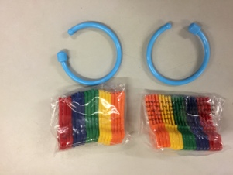
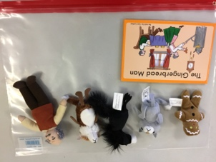
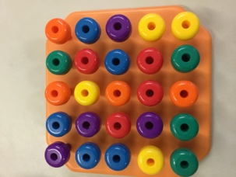
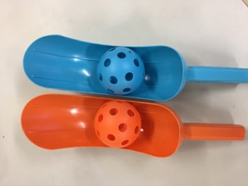

If any other parents wish to come to the workshop, please speak to a member of staff.
Action Cancer will visit nursery on Friday 9th February. We would like each child to donate £1 to give to Action Cancer on the day. This is a wonderful event which explains to children about how to be Happy Healthy Kids in a fun way.
Thanks to everyone for sending in junk materials. Please keep donating, the children are making wonderful models with them.

