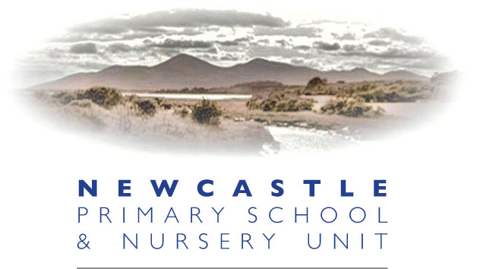

November News 2016
Thursday 10th November – both Nursery classes to Tollymore Forest. P4/5 Shared Education lesson with St Joseph’s PS at NPS.
Friday 11th November - Non-uniform day for “Newcastle Supports Syria”, a community wide campaign to raise awareness and funds for the Syrian Refugees. £1.00 donation per pupil.
Monday 14th November – Sustrans Assembly and class workshops.
Tuesday 15th November – P5 workshop with Newcastle Fire and Rescue Officer at 9.30am
Thursday 17th November – P4/5 trip to Down Museum with St Joseph’s PS. Leaving 9.30am and returning 2.30pm. Packed lunch required.
Friday 18th November - Ditch the Dark, Dr Bike and Children in Need. Non uniform day! Wear something bright so you are easily seen, bring your bike for a health check and wear something spotty for Children in Need! See overleaf for more details.
Guess the number of spots on Roberta's beautiful cake for a chance of winning it! 50p per guess for Children in Need!
Friday 18th November – Nursery Parent/Teacher interviews, see Mrs Bradshaw for times.
Thursday 24th November – Open Evening for all prospective new pupils and their families from 6.30pm to 8.00pm.

Friday 25th November - P7 to Shimna Integrated College Open Day from 9.30am until 2pm. A packed lunch, trainers and a pencil is required.

Please visit www.newcastleps.com for weekly updates and additions.

