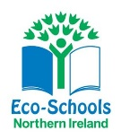

We are all looking forward to our ‘Eco Day’ next Friday 29th April. There will be a lot happening on the day but we need some help!

What to wear?
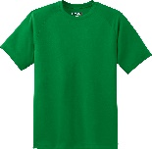
This will be a non-uniform day but we ask that the pupils wear old clothes that they won’t mind getting dirty! We are ‘Going Green’ and would encourage the children to wear something green (socks, hairband, t-shirt, bracelet etc.)

Bring a plant to school
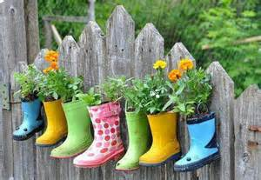
We ask that each pupil brings in a small plant that they can plant in our school grounds. P1 and P2 will be planting in old welly boots and we would appreciate donations of old wellies. Please send the plants and wellies into school before next Friday. Thank you in advance!

Green Break
Keeping with the green theme, we are going to have a ‘Green Break’. Bring in something to eat that is green!

Thank you for your support with this event.
Mrs Hanna
(Eco Co-ordinator)

