We will send you a welcome text from School Money.
Please follow the link and add the password that has been sent to you.
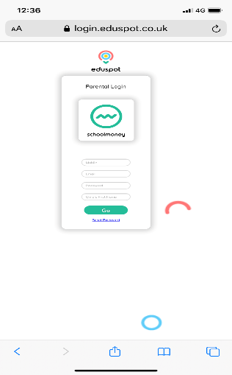
If you have more than one child in school, you will receive a text for each child but when you log in, all your children will show on the same account.
If the log in does not work, please download the app “Teachers2parents” and follow the instructions. 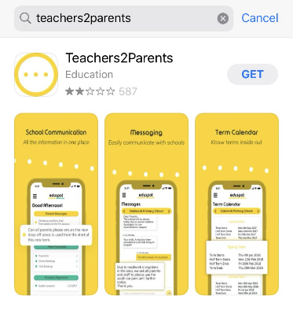
Use the “Dinners” tab to book and pay for school dinners. This must be booked by midnight on the night before the day your child requires school dinners. Please note that free school meals must also be booked through the app too.
Failure to do this will result in your child not being booked in for school dinners so therefore you must provide them with a packed lunch.
School snack is located under the “Clubs” tab and must also be booked and paid for by midnight of the night before the day snack is required.
P1 folders are under the “Payments” tab.
Nursery fund payments will be set up at a later date.

