𝕬𝖚𝖙𝖚𝖒𝖓 𝕱𝖆𝖓𝖈y 𝕯𝖗𝖊𝖘𝖘 𝕯𝖎𝖘𝖈𝖔
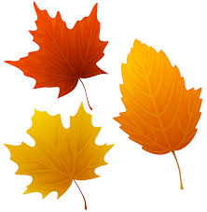
𝐹𝓇𝒾𝒹𝒶𝓎 𝟤𝟧𝓉𝒽 ♡𝒸𝓉♡𝒷𝑒𝓇
9.30am – 10.30am, P1-3
and
11.00am - 12.00pm, P4-7
£𝟚.𝟝𝟘 𝕖𝕟𝕥𝕣𝕒𝕟𝕔𝕖 𝕀𝕟𝕔𝕝𝕦𝕕𝕖𝕤 𝕒 𝕊𝕟𝕒𝕔𝕜 𝔻𝕖𝕒𝕝
𝒲𝑒𝒶𝓇 𝓎𝑜𝓊𝓇 𝒻𝒶𝓋𝑜𝓊𝓇𝒾𝓉𝑒 𝒸𝑜𝓈𝓉𝓊𝓂𝑒
𝑜𝓇
𝑔𝑒𝓉 𝒹𝓇𝑒𝓈𝓈𝑒𝒹 𝓊𝓅
𝒾𝓃 𝓎𝑜𝓊𝓇 𝑔𝓁𝒶𝒹 𝓇𝒶𝑔𝓈!

