October News Afternoon class

The afternoon class are settling into nursery. Thank you for assisting us during the settling in period.

The children are beginning to bring into school conkers and pine cones, please continue to do this. We love to look at leaves and the seeds that fall to the ground in the autumn time. This week we will be looking closely at apples.
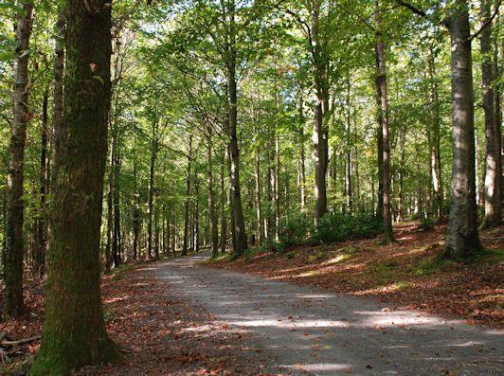
Our first trip will be to Tollymore Forest Park on Thursday 8th November. The afternoon class are to meet at Tollymore forest park car park at 1pm and are to be collected by parents at 2.15 pm at the same place. Please ensure your child is wearing a coat and appropriate shoes/boots for exploring the forest.
If you are available to go with us, please let a member of staff know as soon as possible. The trips are a great learning experience and the children have so much fun, but we do depend on parent volunteers so that we can go on trips into the community. We would love as many parents as possible to come with us, as this is the first trip. For the children it is exciting and reassuring to know a carer is coming with them to the forest park. Parents please do not bring younger children with you and NO PRAMS as we will be exploring the forest and it is very difficult to push prams over rough ground.

Please inform the forest ranger that your child is going on a school trip and you will be told to drive on into the car park to meet nursery staff.

If your child is changed in nursery, staff will probably dress your child in nursery clothes as these are the quickest for us to locate. If your child has been changed, please return these clothes to nursery so that we can use them again. We change lots of children so we would appreciate your cooperation with this matter.

Please write your child’s name on his/her school jumper. The jumpers are all the same and only a few children have a different size of jumper so they get mixed up very easily.

On Thursday 25th October there will be a substitute teacher in nursery as the morning class will be having their parent teacher meetings that day.

We are having our second parent workshop on Thursday 8th November at 7pm - Happy Healthy Kids. We will chat about ways to develop physical skills and healthy eating at home. We will show activities that can be tried at home, which will benefit your child when they start primary school. The staff will demonstrate how to make dough and a healthy snack. We will also show some of the home lending packs which can be borrowed from nursery after this event. The borrowing system will be explained so it is important that parents do attend this event to find out how this system will operate. All the children enjoyed borrowing the packs from nursery last year and we shall be creating some new packs for the children to borrow.
There will be a cup of tea/coffee, plus a free resource for every parent that attends. So that we can prepare for the event please sign the note below to inform us if you are able to attend.

The nursery will be closed for holidays from Friday 26th October to Friday 2nd November inclusive.
We hope you all have fun during the half term holidays.

